Major Findings Summary

Question 1: YouTube Success vs Spotify Success

The analysis aimed to determine the factors influencing the success of a song on YouTube and Spotify. Success was measured as the combined views and streams. The data showed that YouTube had a larger audience than Spotify, with Ed Sheeran's songs "Shape of You" and "Thinking Out Loud" being the only two songs in the top 20 for both platforms. This suggests that YouTube had a more significant impact on the success of songs compared to Spotify.

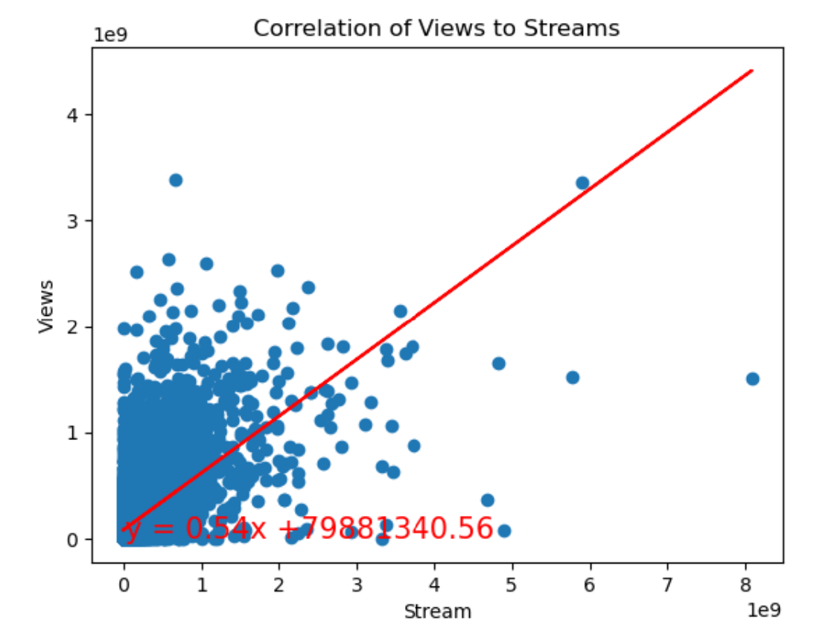

Question 2: Danceability's Influence on Song Success

The analysis investigated whether danceability had an impact on the overall success of a song. The data was sorted by danceability and compared to combined views and streams. The findings showed that there was not a strong correlation between danceability, energy, and song success. Danceability, tempo, and energy did not significantly influence the success of individual songs.

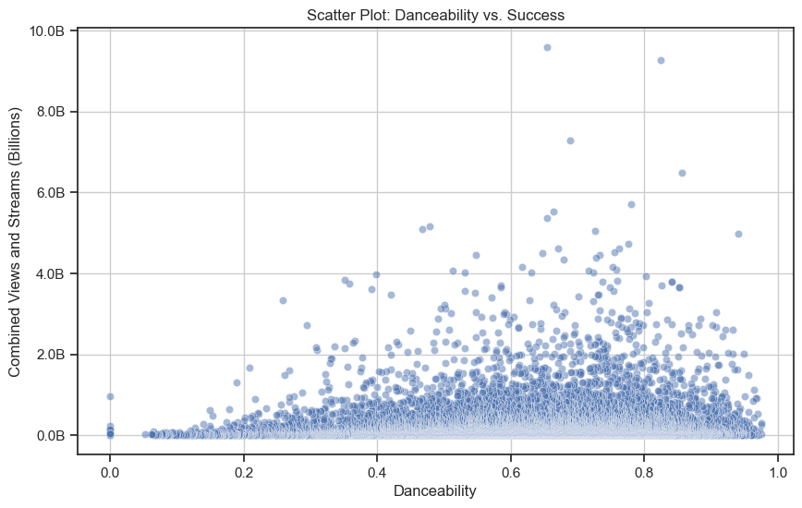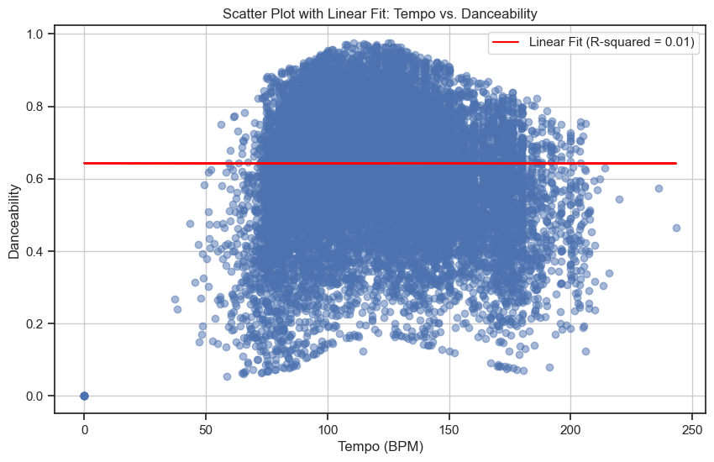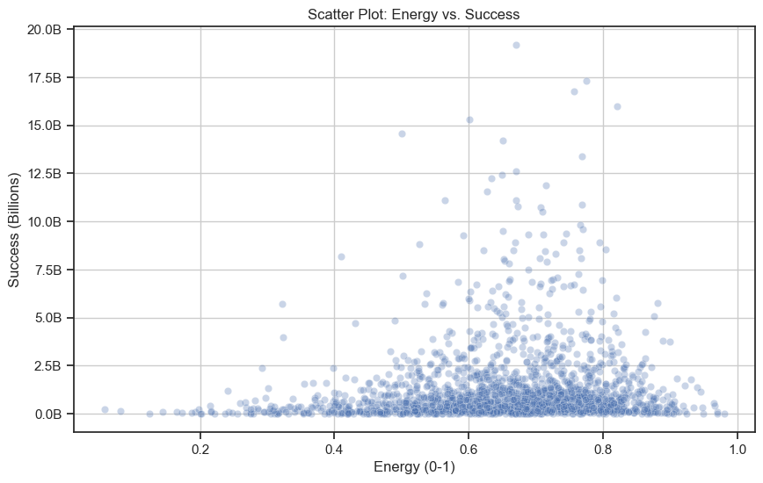

Question 3: Comparing Streams and Views by Album

To determine the top 10 albums based on combined Spotify streams and YouTube views, the data was grouped by albums and filtered to exclude singles. The analysis revealed that albums were more successful, with the top 10 albums having significantly more combined views and streams compared to singles.

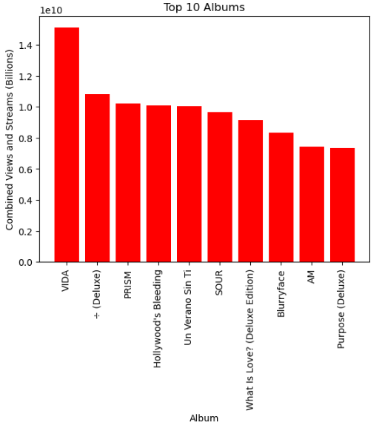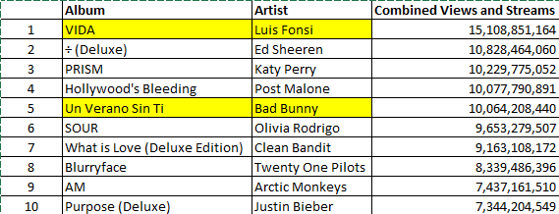

Question 4: Success of a Single vs. an Album

This analysis aimed to answer whether singles or albums were more successful. The data was filtered for the top 100 songs, and success was measured by combined views and streams. Albums were found to be more successful, with the top 100 albums having double the views and streams compared to singles.

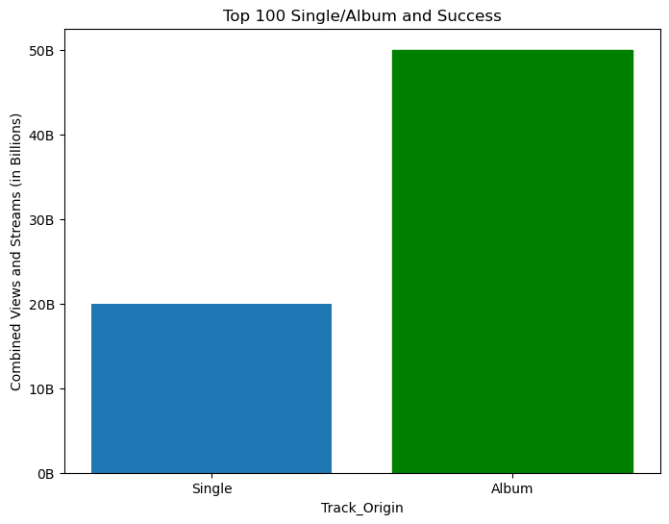

Question 5: Official vs. Unofficial YouTube Videos

The question focused on comparing the success of official and unofficial YouTube videos for the top 100 songs. Official videos were defined as those uploaded by the artist or a recording label. The analysis showed that mostly official YouTube videos were more successful, but a few unofficial videos had made it to the top 100, with a ratio of 25 to 1 between official and unofficial video success.

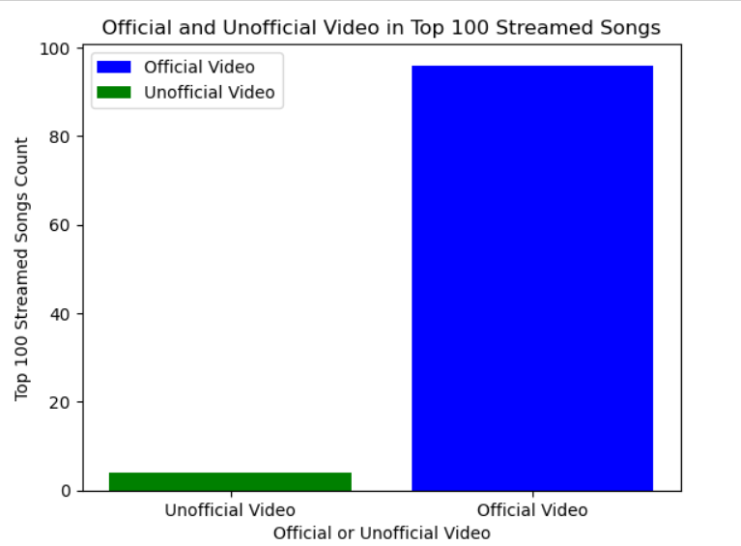

Bonus Analysis: Artist Followers vs. Spotify Streams

An additional analysis examined the relationship between an artist's Spotify follower count and their success in terms of Spotify streams. Ed Sheeran was identified as an artist who was both among the most followed and most streamed artists on Spotify. However, the data was limited to Spotify and did not include information on followers across all social media platforms.

Overall, these findings provide insights into the factors influencing the success of songs on YouTube and Spotify, with a focus on danceability, album vs. single success, official vs. unofficial videos, and artist followers on Spotify.

